MINI DV YSB-001
User Manual

Thank you for purchasing MINI DV—YSB001. It has adopted unique ultra-portable design, which makes it apply to every area. MINI DV—YSB 001 brings more convenience, safety and funs to your daily life.

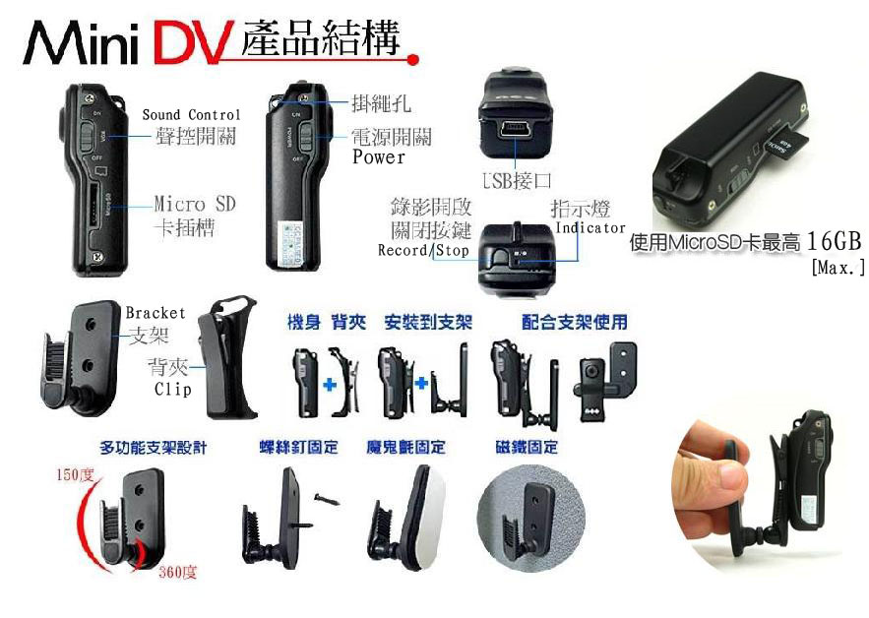
I Characters of Product
- It has small contour design, which does UV spray finishing for the whole body. It is very fashionable and wearable and matches with all kinds of portable tools.
- Support PC camera and chatting function.
- Support AVI video format.
- It can carry out high definition image recording under low illumination.
- Support 30 fps for 720*480 and 320*240 video shoot and output.
- Support USB1.1 and USB2.0.
- Support 8GB T-flash card.(maximum)
- Build-in lithium battery which can make a video more than two hours, the standby time is up to 250 hours.

II Operation Guide

1. Charge
The battery is built-in lithium rechargeable battery, so when you use it the first time, please charge firstly. The method for charging as following:
1.) Connect computer: use USB cable to connect the computer, then it can be charged.
2.) Use adaptor: connect charger plug with USB cable, then plug into electrical connector receptacle, it can be charged.
When you charge it, green light and red light will bright simultaneously, of which states are stillness.

Notice: when battery power is not enough, YSB -001 will enter into protection mode, so it cannot be turn on. Now, please charge for it.

2. Power on to video

- Press Power button slightly, Blue indicator light begins to bright, now it enters into startup ready mode, which can enter into standby mode quickly.
- Press Record / Stop button slightly, Blue indicator light begins to bright, red indicator light starts to flash slowly. At this time, it begins to make a video. The resolution for video file is 720*480, and frame number is 29--30fps/S.
- Then short press Record / Stop button, video is stopped and saved automatically. After saving the red indicator light remains light.
- If you need to continue to video, please press Record / Stop button slightly once more.

Notice:
a. Please make sure T-flash (Micro SD) card has been inserted, if not, it will be power off automatically after 30 seconds.
b. The maximum capacity of T-flash card is 8GB.
c. Saving file needs certain time, so please don’t press Operation button continuously in order to avoid saving unsmoothly and generating incomplete file.
d. When you make a video, please focus on the object and keep 50cm under sufficient illumination. Then the video will be right, natural color, clear and stable.

3. Sound control video (optional)

Press Power button slightly, yellow indicator light begins to bright, now it enters into startup ready mode, which can enter into standby mode quickly. At that time, press MODE button slightly, and then you can switch into sound control video mode. Now Blue indicator light always brights, red indicator light flash quickly (indicate sound control standby mode). When decibel of video is more than 60, then it will be video automatically. At the moment, Blue indicator light always brights, red indicator light flash slowly. (Indicate under sound control video)
When sound control starts, the shortest shoot time is 2 minutes. After 2 minutes, if there is no any sound, D001 will save file automatically and switch into standby mode. If there still has sound after 2 minutes, D001 will continue to shoot.

4．Time set
There is a CD with the product which contains a file named time synchronization file. Please copy it to TF card. When connect YSB-001 with computer, whose time will be displayed with computer synchronously.
The detail as following:
- build a text called TAG.TXT under root directory of card.
- open TAG.TXT,write synchronous date according to enclosure stricktly.
Details as following:
[date] need space with newline
2009/07/22 need space with newline
12：00：00
Power on the machine everytime, system will check and analyse TAG.TXT, then set system time according to file time. After that the text will be deleted by system automatically.

5．Power off
Under video mode or standby mode, please long press Power button 3 seconds, then release till indicator goes out. Then the machine is turned off.

6. Auto-power off function
MINI DV will save file and turn off automatically as following:
a. When you shoot video without enough power, file will be saved automatically, then auto-power off.
b. When disk space of MINI DV is not enoughn, after indicator goes out immediately, file will be saved automatically then auto-power off.
c. Under standby mode, without any operation in 45 seconds, it will be auto-power off.

7．Connecting computer
It can connects computer under power off mode, standby mode or video mode, after that which can be used as U disk, who can copy, cut and paste, delete file.
When you connect it with USB port, a portable disk mark will be seen after several seconds. Red indicator light always brights, yellow indicator light will be from flashed quickly to always brights.

Notice:
a. When you connect computer, if the machine cannot be identified, or not see the portable U disk mark in 30 seconds, please insert it again.
b. It is better copy or cut video file into computer hardware then play. Video file which is saved in the machine is played directly will cause unsmooth play, the reason is that gigantic data cannot be transmitted synchronously.

8 PC Camera
When you first use PC camera, please install driver. The driver name is SPCA1528_V2220_M…Setup.exe, which is placed in attached CD. When you install please double press this document, and as per guide to do. After that there will be an AMCAP icon on the computer desk.
Under power off or power on mode, use USB cable to connect computer, the mode is U disk mode. Then short press MODE button, at this moment it can be switched into PC camera mode. Then double press AMCAP icon can be used as PC camera.

9．Reset
When machine works abnormal for illegal operation or other unknown reasons, it needs to be reset.
The specific operation method as following:
Use slim pole to press the Reset button, and then finish one reset operation.

10. Notice
Suitable using situation: Please follow State's law. Do not use it illegally.
Work temperature: Please use it under normal temperature and avoid using under unsuitable body temperature.
Work humidity: Please use it under agreeable human atmosphere humidity, Please not to make product wet or expose in rain for which without waterproop function.
Shooting illumination: Please use it under enough light sources; do not aim the camera at the sun and other strong light sources in order not to damage optical parts of an apparatus.
Cleaning requirements: Please not use the product under too large dust density atmosphere so as not to affect video effects for tainted lens and other parts.
Waste treatment: Please pay attention to protect environment, not to throw the product optionally. In order to avoid explosion, please not throw product into fire.

